|  |  |
| --- | --- |
| 1 | Travel of an object |

|  |
| --- |
| **Code** |

%Given that

v = 128748 / 3600; %80 miles per hour

theta = 45 * (pi / 180) ; %in radian

g = 9.8 ;

% travel time of flight

Travel_time = (2 * v * sin(theta)) / g

% distance the ball travelled

distance_traveled = v * Travel_time * cos(theta)

Fs = 100;

T = 1 / Fs;

dt = 0:T:Travel_time-T;

high = (v * dt * sin(theta)) - (.5 * g * dt.^2);

plot(dt,(high));

xlabel('Time (sec)'); ylabel('Height (meter)');

title('travel line of the object');

|  |
| --- |
| **Output** |

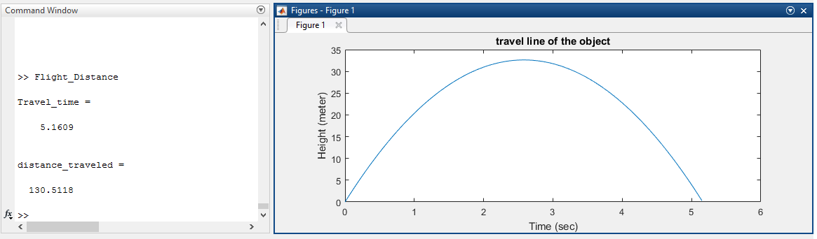

|  |  |
| --- | --- |
| 2 | Compute SNR |

|  |
| --- |
| **Code** |

Fs = 1000 ;

T = 1/Fs ;

f = 5 ;

dt = 0:T:1-T ;

s = 5 * sin(2*pi*f*dt) ; % original signal

n = wgn(1,length(dt),0); % noise signal

x = s + n; % noisy signal

subplot(311);

plot(dt,s); title('Original Signal');

subplot(312);

plot(dt,n); title('Gaussian Noise Signal');

subplot(313);

plot(dt,x); title('Noisy Signal');

SNR = snr(s,n)

|  |
| --- |
| **Output** |

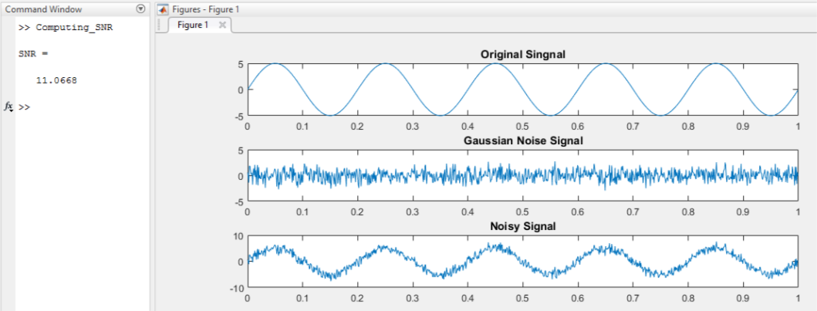

|  |  |
| --- | --- |
| 3 | Discontinuous Signal |

|  |
| --- |
| **Code** |

Fs = 100 ;

T = 1/Fs ;

f = 0.3 ;

dt = 0:T:50-T ;

subplot(211);

y = 5 * sin(2*pi*f*dt) ;

y(y<0) = 0; % if the value is <0 then it is 0

plot(dt,y);

axis([xlim -.2 5.1]); %showing y axis from -.2 to 5.1

xlabel('time (sec)'); ylabel('amplitude');

title('A positive value sine signal');

|  |
| --- |
| **Output** |

